Laporan Praktikum 4

1. Source Code

Web.php => controllers

v_about.php => views

v_footer.php => views

v_header.php => views

v_index.php => views

stylebuku.css => css/assets

1. URL

<http://localhost/pustaka_booking_rina/web>

<http://localhost/pustaka_booking_rina//web/about>

1. Capture Output Program

Tampilan Utama Web

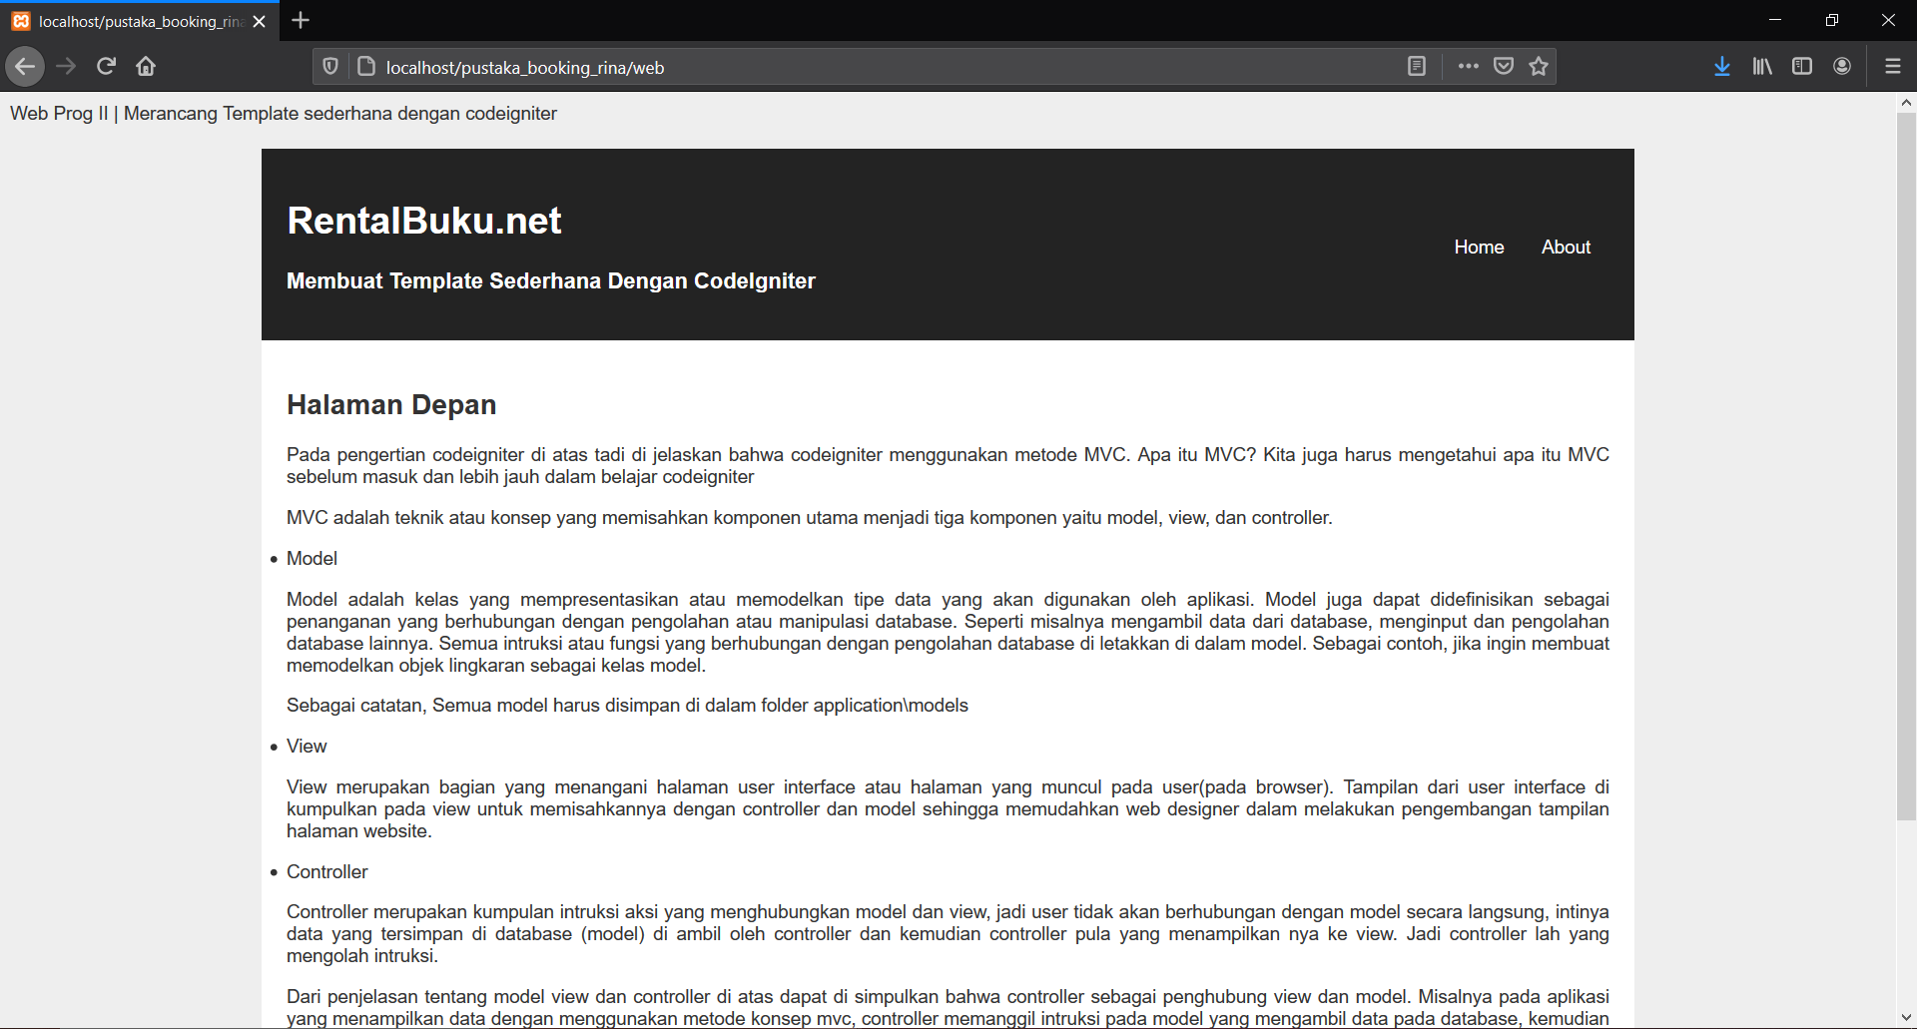

Tampilan About

